Electric Vehicle Data Analytics Using Tableau
Project Documentation
Team no. - 209
Name of the group members:
Raksha Agarwal (Team Lead)-[0103IS231147]- Internet of Things
Akansha Shukla-[0176CD231019]- Data Science
Anushri Tiwari-[0157CY231023]-CSE Cyber Security
Deepak Avachitkar-[0176CD231054]-Data Science
Domain: Electric Vehicles, Data Analytics, Data Visualization

Abstract
Electric Vehicles (EVs) are rapidly transforming the global transportation industry due to their environmental benefits, reduced emissions, and energy efficiency. With the increasing adoption of EVs across cities, large volumes of operational data are generated from charging stations, vehicle sensors, and battery management systems. This data provides valuable insights into charging behavior, energy consumption patterns, battery health, and overall vehicle performance.
This project focuses on the analysis of Electric Vehicle datasets using Tableau, a powerful data visualization tool. The project demonstrates how EV data can be transformed into meaningful insights through interactive dashboards. The analysis is divided into three major areas: charging pattern analysis, battery performance monitoring, and comparative EV model efficiency.
The system provides stakeholders such as city energy planners, fleet managers, and consumers with data-driven insights that can support decision-making. For example, charging pattern analysis can help city planners identify peak electricity demand periods and plan charging infrastructure. Battery performance analytics enables fleet operators to monitor battery degradation and optimize maintenance schedules. Consumers can compare EV models based on range, charging time, and cost efficiency.
The documentation also covers the system architecture, database design, ER diagram, dataset description, and security considerations associated with EV data systems. By combining modern data analytics tools with EV datasets, this project demonstrates how data-driven solutions can contribute to the development of sustainable transportation systems.
This section further discusses the concepts related to abstract. In large-scale EV deployments, analytics systems must process high volumes of operational data generated from vehicles and charging infrastructure. Detailed analysis of such data helps improve energy efficiency, infrastructure planning, and user experience. Visualization tools simplify complex datasets and allow stakeholders to identify trends and make data-driven decisions.
Index / Table of Contents for Documentation

Section | Page No.
1.Introduction of the Team | 1
2. Abstract | 2
3.Index and List of figure | 3-4
4. Introduction | 5
5. Electric Vehicle Technology Overview | 7
6. Role of Data Analytics in EV Ecosystem | 10
7. Problem Statement | 12
8.Objectives of the Project | 14
9. Literature Review | 15
10. System Architecture | 16
11. Database design | 20
12. Entity relationship {ER} diagram | 20
13. Database Tables Description | 18
14. Dataset Description | 21
15. Data Preprocessing | 23
16. Key Performance Metrics | 25
17. Dashboard Design | 27
17. Dashboards Pictures | 29
18. Cybersecurity Considerations | 30
25. Limitations of the Project | 32
26. Future Scope | 33
27. Conclusion | 34
28.Refrence | 36

List of figures
System Architecture | 17
Data Base and design diagram | 20
Key metrics | 24
Unnormalized form | 26
Dashboards | 29
Intrusion prevention system and Defence in depth layer | 31

List of Tables [page no. 18]
EV Model Table
Vehicle Table
Battery Table
Charging Station Table
Charging Session Table

Introduction
Electric Vehicles are automobiles powered by electric motors instead of traditional internal combustion engines. Unlike conventional vehicles that use gasoline or diesel, EVs rely on rechargeable battery packs for energy storage. These batteries power electric motors that drive the vehicle.
The growth of electric mobility is driven by increasing environmental awareness, government incentives, improvements in battery technology, and the global push to reduce greenhouse gas emissions. As EV adoption increases, the amount of data generated by EV systems has also grown significantly.
Modern EVs are advanced mechatronic systems that integrate electrical engineering, embedded systems, and software technologies. Various sensors within the vehicle continuously monitor parameters such as battery voltage, temperature, energy consumption, and vehicle speed. This data can be collected and analyzed to optimize EV performance and infrastructure planning.
Data analytics and visualization tools allow researchers and engineers to analyze EV datasets and extract meaningful patterns. Visualization dashboards can help identify trends in charging behavior, evaluate battery health, and compare the efficiency of different EV models. This project aims to explore these aspects through

In the modern digital era, organizations generate large volumes of data every day. Managing, analyzing, and interpreting this data efficiently has become essential for making informed decisions. Data analytics and database management systems play a crucial role in transforming raw data into meaningful insights that help organizations improve performance, identify trends, and make strategic decisions.
A well-structured database system ensures efficient storage, retrieval, and management of data. Relational database management systems such as PostgreSQL provide powerful tools for handling large datasets while maintaining data integrity and consistency. Database administration tools like pgAdmin make it easier to manage databases, create tables, run queries, and monitor database performance.
In addition to storing data, the ability to visualize and analyze information is equally important. Data visualization tools such as Tableau enable users to create interactive dashboards, charts, and graphs that help in understanding patterns and trends within the data. These visual representations simplify complex datasets and allow users to interpret information quickly and effectively.
This project focuses on designing and implementing a data analytics system using PostgreSQL for database management, pgAdmin for database administration, and Tableau for data visualization. The system is designed to store and manage structured data efficiently while providing meaningful insights through interactive dashboards.
The main objective of this project is to demonstrate how database technologies and data visualization tools can be integrated to create an efficient system for data storage, analysis, and reporting. By combining database management with visualization techniques, the project aims to improve data accessibility, enhance decision-making, and provide a clear understanding of the stored data.

Electric Vehicle Technology Overview
Electric Vehicles consist of several key technological components that work together to provide efficient and sustainable transportation. Understanding these components is essential for analyzing EV datasets.
Battery Pack: The battery pack is the primary energy storage component of an EV. Most modern EVs use lithium-ion batteries due to their high energy density, longer lifespan, and fast charging capability.
Electric Motor: The electric motor converts electrical energy stored in the battery into mechanical energy to drive the vehicle's wheels. Electric motors are highly efficient compared to internal combustion engines.
Battery Management System (BMS): The BMS monitors battery parameters such as voltage, temperature, and state of charge. It ensures safe battery operation and protects against overheating or overcharging.
Power Electronics Controller: This component regulates the flow of electrical energy between the battery and the motor. It controls motor speed and torque based on driver input.
Charging System: EVs are charged using charging stations that supply electrical power. Charging systems can be categorized into Level 1, Level 2, and DC fast charging depending on the power rating.
Electric vehicle technology has evolved rapidly over the last decade due to improvements in battery efficiency and power electronics. Modern EVs rely primarily on lithium-ion batteries because they provide higher energy density and longer life cycles compared to traditional battery technologies. These batteries store electrical energy that powers the electric motor, allowing vehicles to operate with lower emissions and higher efficiency.
Another important technological component in EV systems is regenerative braking. Regenerative braking allows the vehicle to recover energy that would normally be lost during braking and convert it back into electrical energy stored in the battery. This technology significantly improves overall vehicle efficiency and helps extend the driving range of electric vehicles.
Power electronics play a major role in controlling the flow of energy between different components of the EV system. The inverter converts direct current (DC) from the battery into alternating current (AC) used by the motor. Efficient power control systems allow EVs to achieve smoother acceleration, better energy utilization, and improved driving performance.
Charging infrastructure is another critical element in EV technology. Electric vehicles can be charged through various types of charging systems including Level 1 charging, Level 2 charging, and DC fast charging. Faster charging technologies reduce the time required to recharge batteries and make EVs more practical for daily use.
Thermal management systems are also essential in electric vehicles. Batteries and power electronics generate heat during operation, and maintaining optimal temperature levels helps prevent overheating and performance degradation. Advanced cooling systems help improve battery lifespan and ensure safe operation. This section further discusses the concepts related to electric vehicle technology overview. In large-scale EV deployments, analytics systems must process high volumes of operational data generated from vehicles and charging infrastructure. Detailed analysis of such data helps improve energy efficiency, infrastructure planning, and user experience. Visualization tools simplify complex datasets and allow stakeholders to identify trends and make data-driven decisions.

Role of Data Analytics in EV Ecosystem
Data analytics plays a critical role in managing the growing EV ecosystem. Large volumes of data generated by EVs and charging stations must be analyzed to support efficient energy management and infrastructure planning.
Charging pattern analysis helps identify when and where EV owners charge their vehicles. This information is useful for city planners and utility companies that must manage electricity demand across urban areas.
Battery performance analytics allows fleet operators to monitor battery degradation and predict maintenance needs. Early detection of battery issues can reduce operational downtime and improve fleet efficiency.
Consumer decision support is another important application of EV analytics. By comparing different EV models based on efficiency, range, and charging cost, consumers can make informed purchasing decisions.
Data analytics helps organizations understand how electric vehicles are used in real-world conditions. By analyzing operational data collected from vehicles and charging stations, analysts can identify patterns in energy consumption, driving behavior, and charging demand. These insights help improve the efficiency of EV infrastructure.
Another important application of data analytics is battery lifecycle management. Batteries degrade over time due to repeated charging and discharging cycles. Through data analysis, engineers can monitor battery health indicators and predict when maintenance or replacement may be required.
Charging infrastructure planning is also supported by data analytics. By studying charging patterns across different locations and time periods, planners can determine where additional charging stations should be installed. This helps ensure that EV users have convenient access to charging facilities.
Data analytics also assists in optimizing energy consumption within the EV ecosystem. By analyzing electricity usage patterns, energy providers can better manage demand and distribute electricity more efficiently across the power grid.
Visualization tools such as Tableau make it easier to interpret EV datasets. Interactive dashboards allow stakeholders to explore charging trends, vehicle efficiency, and infrastructure usage in a visual format. This improves understanding and supports data-driven decision making.This section further discusses the concepts related to role of data analytics in ev ecosystem. In large-scale EV deployments, analytics systems must process high volumes of operational data generated from vehicles and charging infrastructure. Detailed analysis of such data helps improve energy efficiency, infrastructure planning, and user experience. Visualization tools simplify complex datasets and allow stakeholders to identify trends and make data-driven decisions.

Problem Statement
The rapid growth of electric vehicle adoption introduces several challenges for energy management and transportation systems. One major challenge is the unpredictable charging demand created by EV users. When large numbers of vehicles charge simultaneously, it can place significant pressure on electricity grids.
Another challenge is battery degradation. Over time, EV batteries lose their capacity due to repeated charging cycles. Monitoring battery health is essential for maintaining vehicle performance and planning battery replacements.
Consumers also face difficulty when comparing EV models. Many factors such as range, charging time, battery capacity, and cost must be considered when selecting a vehicle.
Therefore, a data analytics system that can visualize EV datasets and provide meaningful insights is required. This project aims to address this need by developing interactive dashboards using Tableau.
The rapid growth of electric vehicles (EVs) has transformed the transportation industry and created new opportunities for technological innovation. As the adoption of EVs increases globally, large amounts of data are generated from vehicles, charging infrastructure, battery systems, and user interactions. Data analytics plays a crucial role in managing and interpreting this data to improve efficiency, optimize performance, and support the development of a sustainable transportation ecosystem.
One of the most important roles of data analytics in the EV ecosystem is battery performance monitoring and management. The battery is the core component of an electric vehicle, and its performance directly affects vehicle efficiency and driving range. Data collected from battery sensors can be analysed to monitor temperature, charge cycles, voltage levels, and overall battery health. Through data analytics, manufacturers and engineers can identify potential issues, predict battery degradation, and improve battery management systems. This helps extend battery life and ensures reliable vehicle performance.
Data analytics is also widely used to optimize charging infrastructure and energy consumption. With the growing number of EV users, efficient management of charging stations is essential. Analytical models can examine charging patterns, peak demand periods, and energy usage trends to optimize charging station locations and operations. By analysing user behaviour and electricity demand, service providers can design smarter charging networks that reduce waiting times and improve accessibility for EV drivers.
Another significant application of data analytics in the EV ecosystem is predictive maintenance. Electric vehicles contain multiple sensors that continuously generate data related to vehicle performance and component conditions. By analysing this data, predictive maintenance systems can detect early signs of component failure and recommend maintenance before serious problems occur. This approach reduces unexpected breakdowns, minimizes maintenance costs, and improves overall vehicle reliability.
Data analytics also plays an important role in improving vehicle efficiency and driving performance. By studying driving patterns, acceleration behaviour, braking frequency, and energy consumption, manufacturers can optimize vehicle design and software systems. These insights help in improving energy efficiency and extending the driving range of electric vehicles. Drivers can also receive feedback and recommendations to adopt energy-efficient driving habits.
The EV ecosystem also benefits from data analytics in traffic management and route optimization. Navigation systems integrated with analytical models can analyse traffic conditions, road infrastructure, and available charging stations to suggest the most efficient routes for EV drivers. This ensures that vehicles can reach their destination while maintaining optimal energy usage and minimizing travel time.
In addition, data analytics supports policy making and infrastructure planning for governments and urban planners. Authorities can analyse EV adoption trends, charging station utilization, and regional energy demand to design better transportation policies. These insights help governments plan charging networks, improve power grid capacity, and encourage the adoption of sustainable mobility solutions.
Another critical aspect of the EV ecosystem is energy management and integration with renewable energy sources. Electric vehicles interact with the power grid when charging, and large-scale EV adoption can influence electricity demand patterns. Data analytics helps utilities analyse energy consumption trends and balance supply with demand. Smart grid systems can also integrate renewable energy sources such as solar and wind power with EV charging networks to promote sustainable energy usage.
Furthermore, data analytics enhances the customer experience for EV users. By analysing customer preferences, driving habits, and charging behaviour, companies can offer personalized services such as smart charging recommendations, maintenance alerts, and improved navigation systems. These insights help improve user satisfaction and encourage more people to adopt electric vehicles.
Security and data privacy are also important considerations in the EV ecosystem. Large volumes of vehicle and user data must be protected from unauthorized access. Data analytics systems often include security monitoring and anomaly detection mechanisms that identify suspicious activities and prevent potential cyber threats.
In conclusion, data analytics plays a vital role in the development and growth of the electric vehicle ecosystem. It supports battery management, charging infrastructure optimization, predictive maintenance, and efficient energy utilization. By transforming large volumes of data into actionable insights, data analytics enables manufacturers, service providers, and policymakers to improve the performance, reliability, and sustainability of electric vehicles. As the EV industry continues to expand, data analytics will remain a key technology for driving innovation and supporting the transition toward cleaner and smarter transportation systems.

Objectives of the Project
1. Analyze EV charging patterns to identify peak usage hours.
2. Evaluate battery health and performance across different vehicles.
3. Compare EV models based on efficiency, range, and cost.
4. Design a database model for EV data management.
5. Develop interactive dashboards using Tableau.
6. Explore system architecture for EV data analytics platforms.
The primary objective of this project is to develop a data analytics system that can efficiently manage, analyze, and visualize data related to the electric vehicle (EV) ecosystem. With the increasing adoption of electric vehicles, large amounts of data are generated from charging stations, battery systems, and vehicle operations. Proper analysis of this data is necessary to improve efficiency, monitor performance, and support better decision-making.
One of the main objectives of this project is to design a structured database system that can store EV-related data in an organized and efficient manner. A relational database management system such as PostgreSQL is used to manage and store large volumes of data while maintaining accuracy, consistency, and reliability. Proper database design techniques such as normalization are applied to reduce redundancy and improve data integrity.
Another important objective is to analyze EV ecosystem data using analytical tools. Data analytics helps in identifying trends, patterns, and relationships within the dataset. Through proper analysis, it becomes easier to understand charging behavior, vehicle performance, and energy consumption patterns.
The project also aims to create interactive data visualizations and dashboards using Tableau. Visualization tools make complex data easier to understand by presenting it in graphical formats such as charts, graphs, and dashboards. These visual insights help users quickly identify key trends and patterns in EV-related data.
Another objective of the project is to improve decision-making through data-driven insights. By analyzing EV data and presenting it through dashboards, stakeholders can gain valuable information that helps them plan infrastructure, monitor performance, and improve operational efficiency.
The project also focuses on demonstrating the integration of multiple technologies including PostgreSQL for data storage, pgAdmin for database administration, and Tableau for data visualization. This integration creates a complete data analytics environment where data can be stored, managed, analyzed, and visualized effectively.
Overall, the project aims to demonstrate how modern data analytics tools can be used to build an efficient system that supports the analysis and visualization of electric vehicle ecosystem data.
The scope of this project focuses on developing a data analytics framework for analyzing and visualizing information related to the electric vehicle ecosystem. The system is designed to manage structured EV-related data and generate meaningful insights that can help improve understanding of vehicle performance, charging infrastructure, and energy usage patterns.
The project includes the design and implementation of a relational database to store EV-related datasets. The database is developed using PostgreSQL and managed through pgAdmin, which allows users to create tables, execute queries, and maintain data efficiently. Proper database design principles are applied to ensure the system remains organized and scalable.
Another key part of the project scope is data analysis and interpretation. The stored data is analyzed to identify important patterns and trends related to electric vehicles and charging systems. This analysis helps in understanding how EV data can be used to support operational improvements and better infrastructure planning.
The project also includes the development of interactive dashboards using Tableau. These dashboards present analytical results in visual formats such as graphs, charts, and performance indicators. Visualization improves the accessibility of data insights and allows users to easily interpret complex information.
The scope of the project also involves demonstrating how data analytics can contribute to the improvement of EV ecosystem management. By analyzing operational data, organizations can monitor system performance, identify potential issues, and make informed decisions.
However, the project is limited to data analysis and visualization using existing datasets and does not include real-time vehicle data collection or hardware integration. The system is designed primarily for analytical and demonstration purposes to illustrate the potential benefits of data analytics within the EV ecosystem.

Literature Review
The development of modern data-driven applications has significantly increased the importance of efficient database management systems and data visualization tools. Several studies and research works have explored methods for managing large datasets, ensuring data integrity, and presenting insights through visual dashboards.
According to Elmasri and Navathe (2016), database management systems play a critical role in organizing, storing, and retrieving data efficiently. Relational database systems such as PostgreSQL provide structured storage using tables, keys, and relationships, which help maintain data consistency and reduce redundancy. Concepts like normalization, including First Normal Form (1NF), Second Normal Form (2NF), and Third Normal Form (3NF), are widely used to design optimized database schemas.
Research by Silberschatz, Korth, and Sudarshan (2019) highlights the importance of structured query language (SQL) in interacting with relational databases. SQL enables users to perform operations such as data insertion, retrieval, updating, and deletion while ensuring efficient query processing.
In recent years, data visualization tools have become essential for analyzing and interpreting large datasets. Tableau is one of the most widely used business intelligence tools that allows users to create interactive dashboards and visual analytics. According to Tableau documentation, visual representations such as charts, graphs, and dashboards help users understand patterns, trends, and insights more effectively compared to raw data.
Database administration tools such as pgAdmin provide graphical interfaces that simplify database management tasks. These tools help developers and analysts create tables, execute SQL queries, manage relationships, and monitor database performance.
Additionally, modern systems emphasize data security and performance monitoring. Cybersecurity practices such as authentication, secure database access, and network protection ensure that sensitive data remains protected from unauthorized access.
The existing literature indicates that combining relational databases with visualization tools provides an efficient solution for managing and analyzing data. Therefore, this project utilizes PostgreSQL for database management, pgAdmin for database administration, and Tableau for visualization to create a comprehensive system for data storage, analysis, and presentation.

System Architecture
The EV analytics platform follows a multi-layer architecture that enables efficient data collection, storage, processing, and visualization.
Data Generation Layer: This layer includes EV sensors, charging stations, and battery management systems that generate operational data.
Data Collection Layer: Data generated by EV systems is transmitted through APIs or IoT gateways to centralized servers.
Data Storage Layer: Collected data is stored in structured databases or cloud storage platforms.
Data Processing Layer: Raw data is cleaned, filtered, and transformed into structured formats suitable for analysis.
Visualization Layer: Tableau dashboards present insights through charts, graphs, and interactive filters.
Decision Layer: Stakeholders use insights from dashboards to make informed decisions.
System architecture refers to the overall structure of the system and the way different components interact with each other to perform specific functions. In this project, the system architecture is designed to manage, process, and visualize electric vehicle (EV) ecosystem data efficiently. The architecture integrates multiple technologies including a database management system, database administration tools, and data visualization platforms to create a complete data analytics environment.
The system architecture consists of several layers that work together to collect, store, analyze, and present EV-related data. These layers include the data source layer, database layer, data processing layer, and visualization layer. Each layer performs a specific role in the overall functioning of the system.
The data source layer represents the origin of the data used in the system. In the EV ecosystem, data can be generated from multiple sources such as electric vehicles, battery management systems, charging stations, and user interaction records. These sources produce information related to vehicle performance, charging patterns, energy consumption, and operational activities. This raw data forms the foundation of the analytics system.
The next component of the architecture is the database layer, where the collected data is stored in a structured format. In this project, PostgreSQL is used as the relational database management system to store EV-related datasets. The database organizes data into tables and maintains relationships between them using primary keys and foreign keys. This structured storage ensures data consistency, integrity, and efficient retrieval. Database management tasks such as table creation, query execution, and data management are performed using pgAdmin.
After the data is stored in the database, it moves to the data processing and analysis layer. In this stage, SQL queries are used to extract relevant information from the database. Data processing helps in organizing and preparing the dataset for analysis by filtering unnecessary information and performing calculations where required. Analytical operations help identify patterns, trends, and relationships within the EV data.
The visualization layer represents the final stage of the system architecture. In this layer, the processed data is connected to Tableau, which is used to create interactive dashboards and graphical representations. Tableau converts complex datasets into visual formats such as charts, graphs, and dashboards, making it easier for users to interpret the information. These dashboards provide insights into key performance indicators such as charging trends, vehicle usage patterns, and system performance.
Another important aspect of the system architecture is data security and access control. Since the system manages valuable data, it is necessary to ensure that only authorized users can access the database and dashboards. Database security mechanisms such as authentication and role-based access control help protect the data from unauthorized access.
The integration of PostgreSQL, pgAdmin, and Tableau creates a complete data analytics system that allows users to store, manage, analyze, and visualize EV ecosystem data effectively. PostgreSQL handles structured data storage, pgAdmin simplifies database administration, and Tableau provides powerful visualization capabilities.
In conclusion, the system architecture provides a structured framework for managing EV ecosystem data and transforming it into meaningful insights. By combining database technologies with data visualization tools, the system supports efficient data analysis and helps users understand complex EV data in a clear and organized manner.

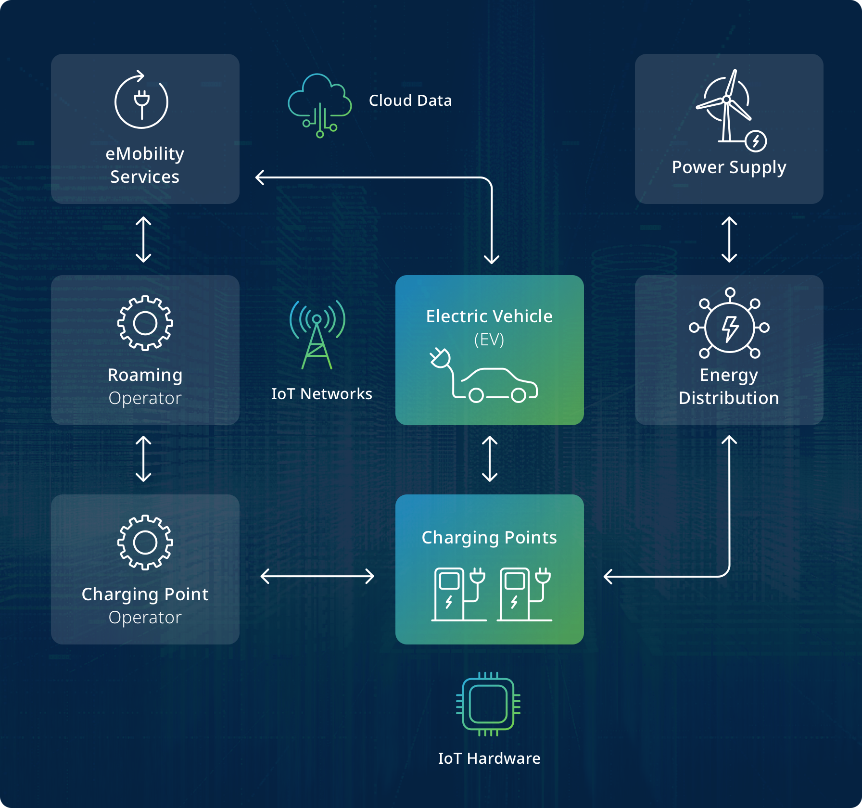

EV_Model Table
Model_ID (PK) | Manufacturer | Battery_Capacity_kWh | Range_km | Efficiency_km_per_kWh
M101 | Tesla | 75 | 450 | 6
M102 | Nissan | 60 | 380 | 6.3

Vehicle Table
Vehicle_ID (PK) | Model_ID (FK) | Battery_ID (FK) | Owner_Type
V201 | M101 | B301 | Taxi Fleet
V202 | M102 | B302 | Private

Battery Table
Battery_ID (PK) | Capacity_kWh | State_of_Health | Cycle_Count
B301 | 75 | 92% | 450
B302 | 60 | 95% | 300

Charging_Station Table
Station_ID (PK) | Location | Power_Rating_kW
S401 | City Center | 50
S402 | Mall Parking | 22

Charging_Session Table
Session_ID (PK) | Vehicle_ID (FK) | Station_ID (FK) | Start_Time | End_Time | Energy_kWh
CS501 | V201 | S401 | 10:00 | 11:00 | 32
CS502 | V202 | S402 | 18:30 | 19:10 | 18

Database Design and ER Model
Efficient data management is essential for EV analytics. A relational database model is used to organize EV datasets and avoid redundancy.
The system contains several entities including Vehicle, Battery, Charging Session, Charging Station, and EV Model.
Vehicle Table: Stores information about individual vehicles such as vehicle ID, model ID, and battery ID.
Battery Table: Stores battery specifications and health indicators.
Charging Station Table: Contains details about charging locations and power ratings.
Charging Session Table: Records charging events including start time, end time, and energy consumed.
EV Model Table: Contains specifications for different EV models.
the concepts related to database design and er model. In large-scale EV deployments, analytics systems must process high volumes of operational data generated from vehicles and charging infrastructure. Detailed analysis of such data helps improve energy efficiency, infrastructure planning, and user experience. Visualization tools simplify complex datasets and allow stakeholders to identify trends and make data-driven decisions. Database design is a critical step in developing an efficient data analytics system. It defines how data is organized, stored, and managed within the database. A well-designed database structure ensures data consistency, reduces redundancy, and allows efficient data retrieval. In this project, a relational database management system is used to store and manage electric vehicle (EV) ecosystem data. PostgreSQL is used as the primary database platform, while pgAdmin is used for database administration and management.
The database design process begins with identifying the key entities involved in the EV ecosystem and defining the relationships between them. Entities represent real-world objects or components of the system such as vehicles, charging stations, charging sessions, and users. Each entity contains attributes that describe its properties. For example, the vehicle entity may include attributes such as vehicle ID, model name, battery capacity, and manufacturer. Similarly, the charging station entity may contain attributes such as station ID, location, charging type, and availability status.
Once the entities and their attributes are identified, tables are created in the database to store this information. Each table contains a primary key that uniquely identifies each record. Relationships between tables are established using foreign keys. These relationships help maintain data integrity and allow efficient linking of related information across multiple tables.
For example, a Vehicle table stores details about different electric vehicles, while a Charging Station table stores information about available charging infrastructure. A Charging Session table records charging activities and connects vehicles with charging stations using foreign keys. This relational structure helps organize the EV ecosystem data in a structured format and allows efficient querying and analysis.
To further improve the database structure, normalization techniques are applied during the design process. Normalization helps eliminate duplicate data and ensures that each table stores only relevant information. By organizing data into separate related tables, the system becomes more efficient, easier to maintain, and less prone to data inconsistencies.
The Entity Relationship (ER) Diagram is a visual representation of the database structure. It illustrates the entities, attributes, and relationships within the system. ER diagrams help developers understand how data flows through the system and how different components are connected. They also serve as a blueprint for implementing the database in PostgreSQL.
In this project, the ER diagram shows the relationship between major entities such as vehicles, charging stations, charging sessions, and users. Each entity is represented as a table with attributes, while relationships between them are represented using connecting lines. The ER diagram helps ensure that the database structure is logically organized and supports efficient data management and analysis.
Overall, the database design provides a structured framework for storing and managing EV ecosystem data. By using PostgreSQL and applying proper database design principles, the system ensures reliable data storage, efficient data retrieval, and effective support for data analytics and visualization.

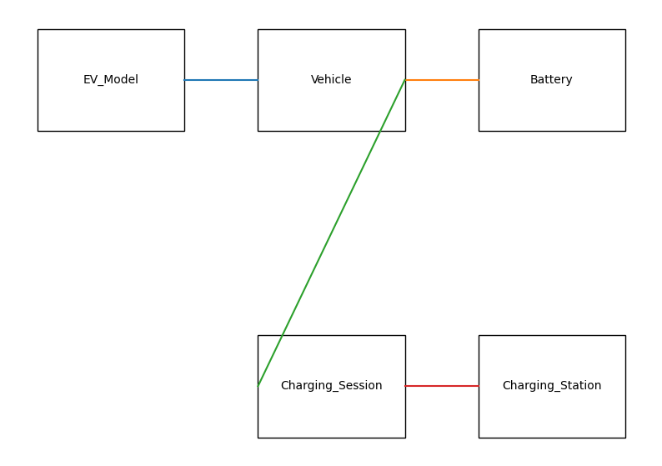

Dataset Description
Three datasets are used in this project. The first dataset records charging patterns including charging time, location, and energy consumed.
The second dataset contains battery performance information including state of charge, state of health, and driving range.
The dataset used in this project contains information related to the electric vehicle (EV) ecosystem. It includes data about electric vehicles, charging stations, charging sessions, energy consumption, and operational performance. This dataset plays an important role in analyzing EV infrastructure, understanding charging behavior, and identifying patterns related to electric vehicle usage. By using this dataset, the system can generate insights that support data-driven decision making and improve the efficiency of EV-related services.
The dataset consists of multiple attributes that describe different aspects of the EV ecosystem. These attributes include information about vehicles, charging station locations, charging duration, energy consumption, battery performance, and user activity. Each record in the dataset represents a specific event or data entry related to electric vehicle operations. The data is organized in a structured format so that it can be stored efficiently in a relational database system such as PostgreSQL.
One important component of the dataset is the vehicle-related information. This includes details such as vehicle ID, vehicle model, manufacturer, battery capacity, and vehicle type. These attributes help identify different types of electric vehicles and analyze their performance characteristics. Vehicle-related data allows analysts to study how different EV models perform under various conditions and how battery capacity influences driving range and charging requirements.
Another important part of the dataset contains charging station information. Charging station data includes attributes such as station ID, station location, charging type, availability status, and power capacity. This information helps in understanding the distribution and accessibility of charging infrastructure. By analyzing charging station data, organizations can identify areas with high demand for charging services and plan infrastructure expansion accordingly.
The dataset also includes charging session records, which capture detailed information about individual charging activities. Charging session data may include session ID, vehicle ID, charging station ID, start time, end time, energy consumed, and charging duration. This data is useful for analyzing charging behavior, identifying peak usage times, and evaluating the efficiency of charging infrastructure.
In addition to charging and vehicle data, the dataset may also contain energy consumption and battery performance metrics. These attributes provide insights into how energy is used during vehicle operation and charging processes. By analyzing energy consumption patterns, it becomes possible to identify inefficiencies and recommend improvements in charging strategies and energy management.
The dataset is processed and stored in a PostgreSQL database where it is organized into multiple tables based on the entity relationships identified during database design. Each table represents a specific entity such as vehicles, charging stations, or charging sessions. Relationships between these tables are established using primary keys and foreign keys to ensure data consistency and integrity.
Before performing analysis, the dataset undergoes data preparation and cleaning processes. These processes include removing duplicate entries, handling missing values, and ensuring that the data follows a consistent format. Data preprocessing helps improve the accuracy and reliability of analytical results.
After the dataset is stored and processed, it is connected to the visualization tool Tableau. Tableau uses the dataset to create interactive dashboards and graphical reports that display important metrics such as charging trends, station utilization, and vehicle performance. These visualizations help users easily understand complex data and identify meaningful patterns.
Overall, the dataset serves as the foundation for the entire data analytics system. It provides the necessary information required to analyze EV ecosystem performance and generate insights. By organizing and analyzing this dataset using PostgreSQL, pgAdmin, and Tableau, the project demonstrates how structured data management and visualization techniques can be used to better understand and improve electric vehicle infrastructure and operations.

Data Preprocessing
Data preprocessing is an important step in analytics projects. Raw datasets often contain missing values, inconsistent formats, or duplicate records.
During preprocessing, duplicate entries are removed and missing values are handled appropriately.
Data normalization is performed to ensure consistency across datasets.
Data preprocessing is an important step in the data analytics process. Raw datasets often contain incomplete information, duplicate records, or inconsistent values that can affect the accuracy of analysis. Data preprocessing involves cleaning, organizing, and transforming the raw data into a structured format that can be easily analyzed. In this project, data preprocessing was performed before storing the dataset in the PostgreSQL database and before connecting it to the visualization tool for analysis.
The first step in data preprocessing is data cleaning. During this stage, the dataset is examined carefully to identify missing values, duplicate entries, and incorrect data records. Missing data fields can cause errors during analysis, so these values are either corrected, replaced with appropriate values, or removed when necessary. Duplicate records are also removed to ensure that the dataset contains only unique and accurate information. Data cleaning improves the overall quality and reliability of the dataset.
Another important step in preprocessing is data formatting and standardization. Data collected from different sources may be stored in various formats, which can create inconsistencies. For example, date formats, numerical values, and text fields must follow a consistent structure to ensure proper processing. During this stage, data values are converted into a standardized format so that they can be stored efficiently in database tables and used for further analysis.
The next stage of preprocessing is data transformation. Data transformation involves modifying the dataset to make it more suitable for analysis. This may include converting categorical values into numerical formats, combining related data fields, or calculating additional attributes such as charging duration or energy consumption. These transformations help create meaningful variables that can be used for analytical and visualization purposes.
Another important process is data integration. In many data analytics systems, information may come from multiple sources such as vehicle data, charging station records, and operational logs. Data integration combines these different datasets into a unified structure so that relationships between them can be analyzed effectively. In this project, related data elements such as vehicle details, charging station information, and charging session records are organized into separate tables within the PostgreSQL database and connected using relational keys.
After cleaning and transforming the dataset, the data is validated to ensure accuracy and consistency. Data validation checks whether the values stored in the database follow predefined rules and constraints. For example, numerical fields such as energy consumption or charging duration must contain valid numerical values, and primary key fields must remain unique for each record. Validation helps prevent errors and ensures that the dataset is reliable for analysis.
Finally, the preprocessed dataset is loaded into the PostgreSQL database and connected to the data visualization platform. The clean and structured dataset allows analytical tools such as Tableau to generate accurate visual insights. The preprocessing stage ensures that the data used for visualization and analysis is consistent, reliable, and ready for generating meaningful reports and dashboards.

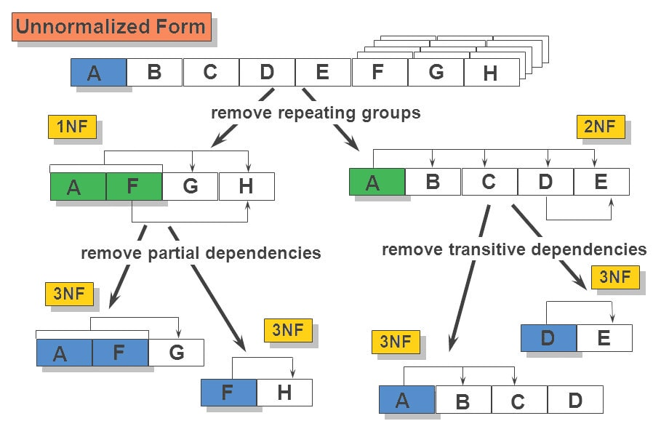
[(3NF) Third Normal Form eliminates transitive dependency from the database. In this stage, non-key attributes depend only on the primary key, ensuring data integrity and reducing redundancy. The database tables are separated logically to maintain consistency.]

Key Performance Metrics
Efficiency (km/kWh): This metric measures how efficiently an EV uses electrical energy.
Cost per Kilometer: This metric estimates the operational cost of driving an EV based on electricity prices.
Battery Degradation Rate: This metric measures how battery capacity decreases over time.
Peak Charging Demand: This metric identifies the time periods with highest charging activity.
Key Performance Metrics (KPMs) are important indicators used to measure the performance, efficiency, and effectiveness of a system. In a data analytics project related to the Electric Vehicle (EV) ecosystem, these metrics help evaluate how well the system processes data, analyzes patterns, and generates meaningful insights. By monitoring these metrics, organizations and analysts can understand system performance and make informed decisions to improve operations.
One of the important performance metrics in the EV ecosystem is charging station utilization. This metric measures how frequently charging stations are used by electric vehicles. By analyzing this metric, it becomes possible to identify peak usage hours, understand demand patterns, and evaluate whether the existing charging infrastructure is sufficient. High utilization rates may indicate high demand, while low utilization could suggest that certain charging stations are underused.
Another key metric is energy consumption analysis. This metric measures the amount of electrical energy consumed during charging sessions. Monitoring energy consumption helps in understanding how efficiently energy resources are being used. It also allows analysts to identify trends in energy demand and helps energy providers manage electricity distribution more effectively.
Charging session duration is another important performance metric. This metric measures the time taken by a vehicle to complete a charging session. Analyzing charging duration helps in understanding how long EV users occupy charging stations and whether charging technology is efficient. This information can help improve charging infrastructure planning and reduce waiting times at stations.
The vehicle usage and activity rate is also a significant performance indicator. This metric analyzes how frequently electric vehicles are used and how often they require charging. Understanding vehicle usage patterns allows analysts to predict charging demand and plan infrastructure expansion accordingly.
Another important metric is system response and data processing efficiency. Since the project involves database storage and data visualization, it is important to measure how quickly the system retrieves and processes data from the database. Efficient query execution and fast dashboard loading times ensure that users can access insights quickly and without delays.
Data accuracy and consistency is also considered a key performance metric. Since the system relies on stored data to generate analytical insights, it is important to ensure that the dataset remains accurate and free from inconsistencies. Data preprocessing and validation processes help maintain the quality of the data used in the analytics system.
Visualization performance is another important aspect. The ability of the Tableau dashboards to present clear and interactive insights is evaluated through metrics such as dashboard responsiveness and clarity of visualization. Effective visualizations allow users to easily understand trends, patterns, and relationships within the EV dataset.
Overall, key performance metrics help evaluate both the analytical effectiveness and system performance of the EV data analytics platform. By analyzing charging patterns, energy consumption, system response time, and data accuracy, the project demonstrates how data analytics can support better decision-making and improve the management of electric vehicle ecosystems.

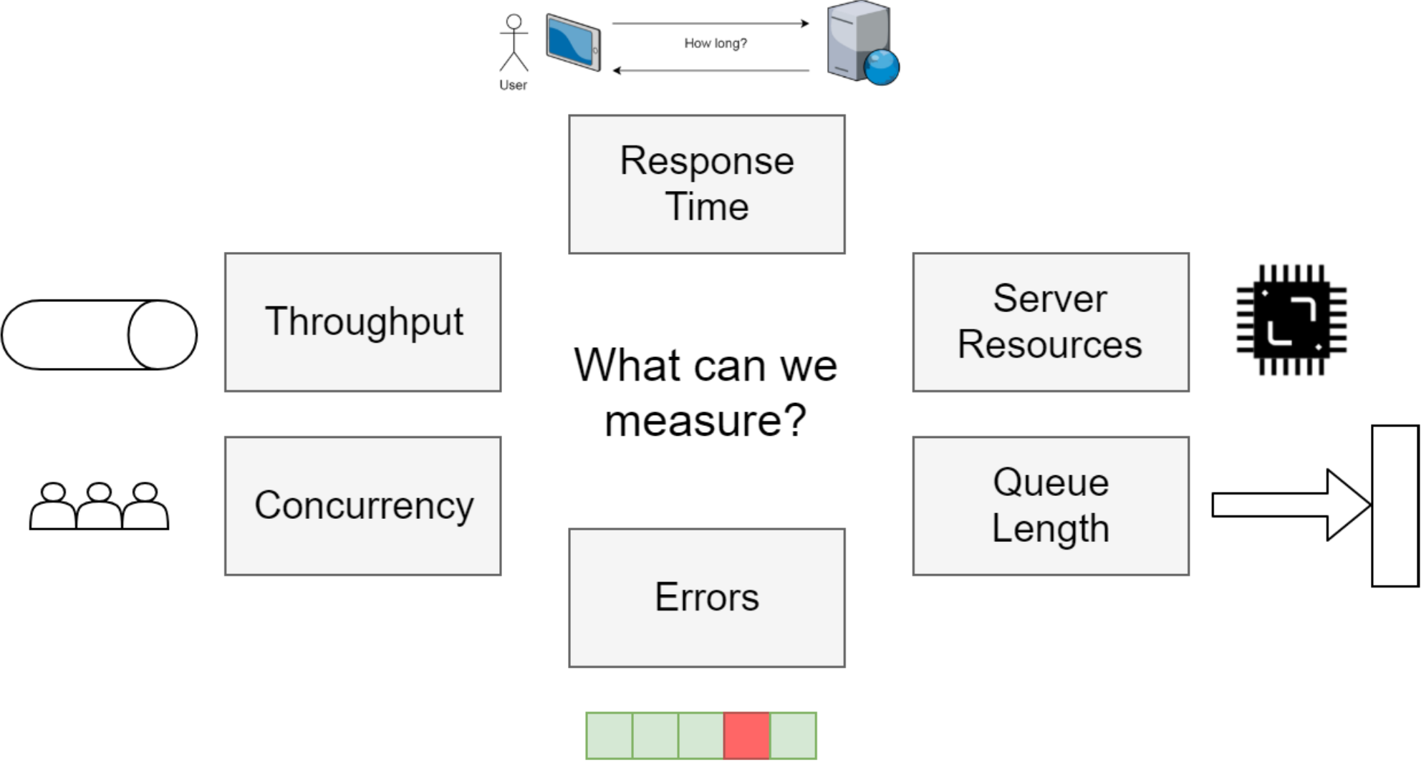

Dashboard Analysis
Charging Pattern Dashboard: This dashboard visualizes charging behavior across different locations and time periods.
Battery Performance Dashboard: This dashboard compares predicted vehicle range with actual range based on battery health.
EV Model Comparison Dashboard: This dashboard allows users to compare EV models based on range, efficiency, and cost.
Dashboard analysis plays an important role in understanding and interpreting the results generated from data analytics systems. In this project, Tableau dashboards are used to visualize the electric vehicle (EV) ecosystem data stored in the PostgreSQL database. The dashboards present complex datasets in graphical formats such as charts, graphs, and indicators, allowing users to easily identify trends, patterns, and performance metrics related to EV operations.
The dashboards are designed to provide insights into different aspects of the EV ecosystem, including charging station utilization, energy consumption patterns, vehicle usage trends, and charging session behavior. By representing the data visually, the dashboards help users quickly understand important information without having to analyze raw data manually.
One of the main components of the dashboard is the charging station utilization analysis. This section of the dashboard displays the usage patterns of different charging stations. It shows how frequently charging stations are used and identifies the stations with the highest demand. By analyzing this information, it becomes easier to understand which locations require additional infrastructure or improved charging capacity.
Another important part of the dashboard focuses on energy consumption analysis. This visualization presents the amount of energy consumed during EV charging sessions over a specific period of time. The dashboard helps identify patterns in energy usage and highlights peak consumption periods. This information can be useful for energy providers and infrastructure planners to manage electricity demand efficiently.
The dashboard also includes a charging session analysis, which displays information about charging duration and session frequency. Charts and graphs show how long vehicles remain connected to charging stations and how often charging sessions occur. This analysis helps identify peak usage times and provides insights into user charging behavior.
Another key feature of the dashboard is the vehicle performance and activity analysis. This section highlights information related to vehicle usage, battery performance, and charging requirements. By analyzing this data, it becomes possible to understand how different electric vehicles perform under various conditions and how frequently they require charging.
The dashboards also include interactive filtering options, which allow users to explore the dataset more effectively. Users can filter data based on variables such as charging station location, vehicle type, time period, or energy consumption levels. These interactive features help users focus on specific data segments and perform more detailed analysis.
Visualization elements such as bar charts, line graphs, pie charts, and KPI indicators are used throughout the dashboard to present information clearly and effectively. These visual tools make it easier to compare different metrics and observe trends over time. By converting numerical data into visual insights, the dashboard improves the overall understanding of the EV ecosystem.
Overall, the dashboard analysis provides a comprehensive overview of the EV dataset and helps identify important patterns related to charging infrastructure, vehicle usage, and energy consumption. The use of Tableau dashboards enables efficient data exploration and supports data-driven decision making. By combining database management with interactive visualization tools, the project demonstrates how data analytics can improve the monitoring and management of electric vehicle systems.

Dashboards: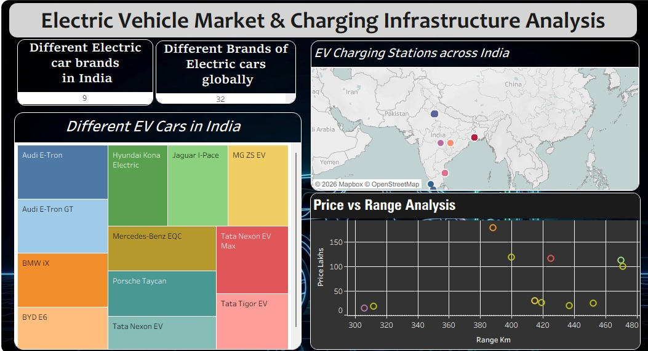
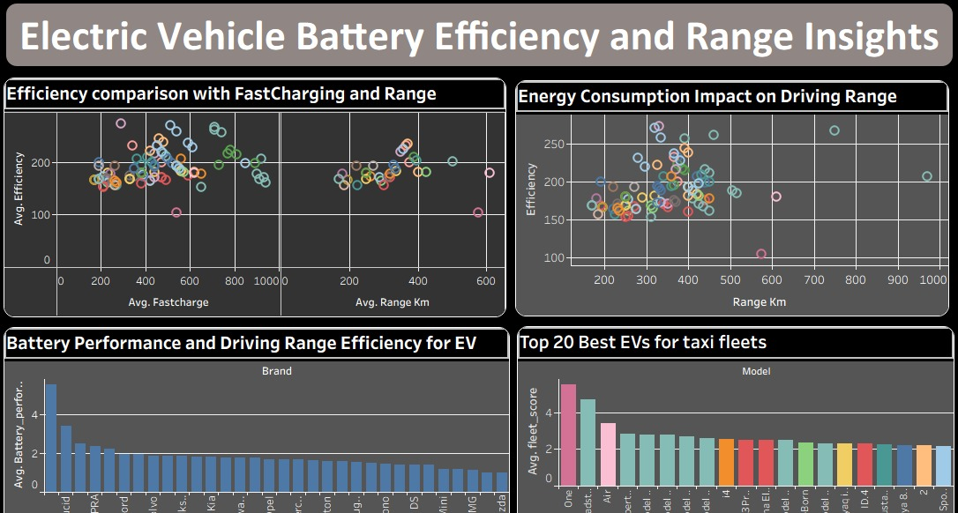
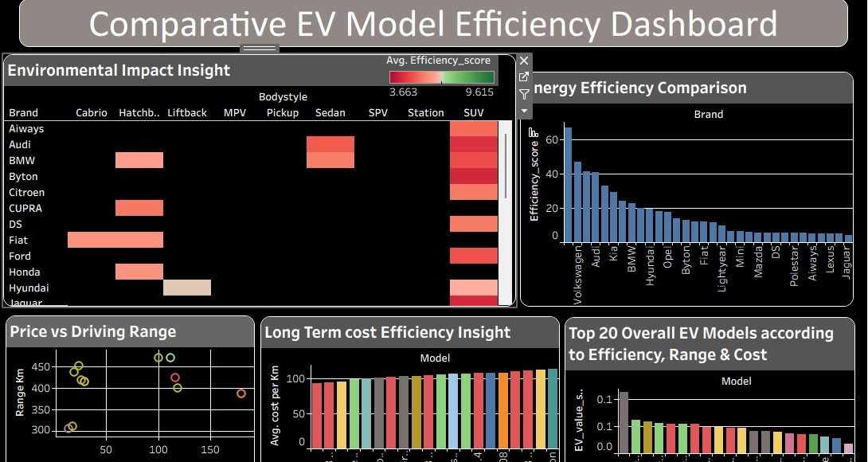

Cybersecurity Considerations
Electric vehicle data systems must be designed with strong security measures to protect sensitive information.Potential risks include unauthorized access to user data, charging station hacking, and data interception during transmission.Security measures include encryption protocols, secure APIs, authentication mechanisms, and access control systems.Cloud platforms also implement identity and access management policies to protect EV datasets.Cyber security plays an essential role in modern data-driven systems, especially in environments where large volumes of sensitive information are generated and stored. In the electric vehicle (EV) ecosystem, data is collected from multiple sources such as vehicles, charging stations, battery management systems, and user applications. This data may include operational details, energy consumption patterns, location information, and user-related records. Protecting this information from unauthorized access, misuse, or cyber threats is a critical requirement for ensuring the reliability and trustworthiness of the system.
One of the primary cyber security considerations in this project is data confidentiality. Confidentiality ensures that sensitive information stored in the database is accessible only to authorized users. Since the system stores EV-related data within a PostgreSQL database, access control mechanisms must be implemented to restrict unauthorized access. User authentication and role-based access permissions help ensure that only approved users can perform operations such as data retrieval, modification, or deletion.
Another important security aspect is data integrity. Data integrity ensures that the stored information remains accurate, consistent, and protected from unauthorized modifications. If attackers or unauthorized users manipulate the data stored in the database, it could lead to incorrect analysis results and unreliable decision-making. To prevent such issues, database constraints, validation rules, and transaction controls are used. These mechanisms ensure that only valid data is entered into the system and that changes to the database follow predefined rules. Authentication and authorization mechanisms also play a vital role in securing the system. Authentication verifies the identity of users attempting to access the system, while authorization determines what actions those users are allowed to perform. By implementing secure login credentials and access levels, the system ensures that users only access the data and functions that are relevant to their roles.
Another key consideration is network security. Since the system involves communication between databases and visualization tools, it is important to secure the network through which data is transmitted. Secure communication protocols and network protection mechanisms help prevent unauthorized interception of data during transmission. Firewalls and network monitoring tools can also be used to detect suspicious activity and prevent cyber attacks.
Data encryption is another important security practice used to protect sensitive information. Encryption converts readable data into a secure encoded format that can only be accessed using authorized decryption keys. This helps protect stored data as well as data transmitted between the database and visualization platforms. Encryption ensures that even if data is intercepted, it cannot be easily understood or misused by unauthorized individuals. The system must also address cyber threats such as malware, phishing attacks, and unauthorized system access. Organizations managing EV data must implement strong security policies and regularly update their systems to prevent vulnerabilities. Software updates, security patches, and regular monitoring help reduce the risk of cyber attacks. Data backup and recovery strategies are another important component of cyber security. Unexpected events such as system failures, cyber attacks, or data corruption can result in the loss of important information. Regular database backups ensure that the system can recover quickly in case of such incidents. Backup copies of the data allow organizations to restore the system without losing critical information.
In addition to technical security measures, data privacy considerations must also be addressed. Since EV data may contain information related to user behavior and location, it is important to ensure that this information is handled responsibly. Data privacy policies should be implemented to ensure that personal information is not misused or shared without authorization. Monitoring and auditing are also essential aspects of cyber security. By maintaining system logs and monitoring database activity, administrators can track user actions and detect unusual behavior. These logs provide valuable information that can help identify security breaches and investigate suspicious activities. Another important aspect of cyber security in EV data analytics systems is secure integration of different technologies. Since the project integrates PostgreSQL for data storage, pgAdmin for database management, and Tableau for visualization, it is important to ensure that these tools communicate securely with each other. Secure configurations and proper access controls help maintain system stability and prevent vulnerabilities during system integration.
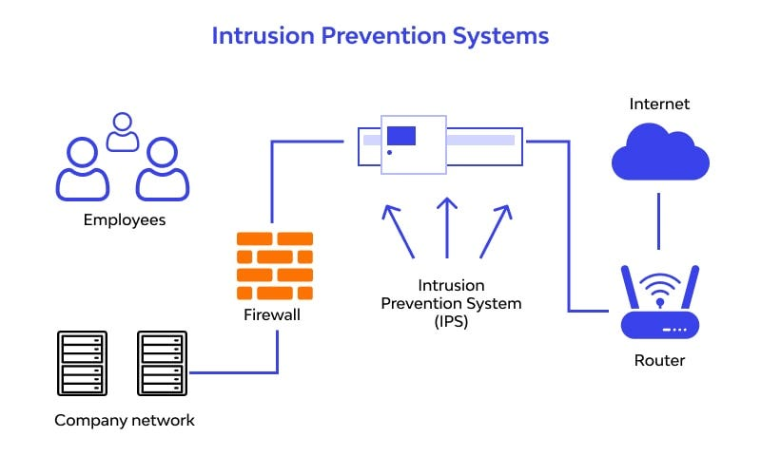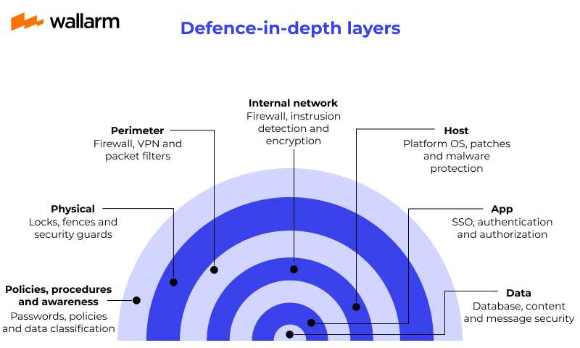

Limitations
This project uses simulated or limited datasets which may not represent real-world EV systems perfectly.
Real-time data streaming from IoT devices is not implemented in this prototype system.
Environmental variables such as weather conditions are not considered in the analysis.
Although the project provides useful insights into the electric vehicle (EV) ecosystem through data analytics and visualization, there are certain limitations that affect the overall scope and functionality of the system. These limitations arise due to constraints related to data availability, system implementation, and project scope.
One of the main limitations of the project is the availability and quality of the dataset. The analysis in this project is based on a predefined dataset rather than real-time data collected directly from electric vehicles or charging infrastructure. As a result, the insights generated from the analysis may not fully represent real-world EV operations. In practical applications, EV systems generate dynamic and continuously changing data, which requires real-time processing and monitoring. Another limitation is related to real-time data integration. The current system focuses primarily on data storage, analysis, and visualization using existing datasets. It does not include mechanisms for real-time data collection from sensors, charging stations, or connected vehicles. Implementing real-time data streaming would require advanced technologies such as IoT integration, cloud computing, and real-time analytics platforms. The project is also limited in terms of system scalability. While PostgreSQL is capable of handling large datasets, the current implementation is designed mainly for demonstration and analytical purposes. In large-scale EV ecosystems with millions of records and continuous data generation, additional infrastructure such as distributed databases, cloud platforms, and big data technologies may be required to manage and process the data efficiently. Another limitation is the restricted scope of analytical models used in the project. The analysis mainly focuses on descriptive analytics through dashboards and visualizations. Advanced analytical techniques such as predictive analytics, machine learning models, or AI-based forecasting have not been implemented in this project. These techniques could provide deeper insights, such as predicting charging demand or estimating battery performance trends.
The visualization component of the system is also limited to dashboard-based insights created using Tableau. While Tableau provides powerful visualization capabilities, the dashboards mainly represent historical data trends and do not include advanced interactive analytics or automated decision-making features. Security implementation within the project is also basic and primarily focuses on standard database security practices such as authentication and controlled access. In real-world EV ecosystems, more advanced cyber security mechanisms such as intrusion detection systems, secure network architectures, and continuous monitoring would be required to protect sensitive data and ensure system safety. Another limitation is related to geographical and operational coverage. The dataset used in the project may represent a specific region or limited set of EV operations. Therefore, the results may not be applicable to all EV markets or regions where charging infrastructure, vehicle technology, and user behavior may differ.
Despite these limitations, the project successfully demonstrates the use of database management systems and data visualization tools for analyzing EV ecosystem data. The system provides a foundational framework that can be expanded in the future with real-time data integration, advanced analytics, and improved infrastructure to support large-scale EV data management.

Future Scope
The rapid development of electric vehicle (EV) technology and data analytics presents many opportunities for improving the system developed in this project. While the current system focuses on analysing EV ecosystem data using PostgreSQL, pgAdmin, and Tableau, there are several areas where the system can be expanded and enhanced in the future.
One of the most significant improvements that can be made is the integration of real-time data collection systems. In a real-world EV ecosystem, data is continuously generated by vehicles, charging stations, and battery management systems. Future versions of this project could incorporate Internet of Things (IoT) technologies to collect real-time data directly from EV sensors and charging infrastructure. This would allow the system to monitor EV performance, charging activity, and energy consumption in real time.
Another potential improvement is the implementation of advanced data analytics techniques such as machine learning and predictive analytics. These technologies could help predict charging demand, forecast energy consumption patterns, and estimate battery performance over time. Predictive models could also help infrastructure planners determine where new charging stations should be installed based on historical usage patterns.
The project could also be enhanced by implementing cloud-based data storage and processing systems. As the EV ecosystem continues to grow, the amount of data generated will increase significantly. Cloud computing platforms can provide scalable storage and processing capabilities, allowing the system to handle large volumes of data efficiently. This would also make the system accessible from multiple locations and support collaboration among users.
Another important area for future improvement is enhancing system security and data privacy mechanisms. As EV systems handle sensitive operational and user data, advanced cyber security techniques such as encryption, intrusion detection systems, and secure network communication protocols could be implemented to further protect the system from potential cyber threats.
The visualization component of the system could also be expanded to include more advanced and interactive dashboards. Future dashboards could include real-time monitoring indicators, automated alerts, and deeper analytical features that allow users to explore the data more effectively. These enhancements would improve the overall usability and effectiveness of the analytics platform.
In addition, the system could be extended to support smart grid integration and renewable energy analysis. Electric vehicles are increasingly connected with smart energy systems, and future analytics platforms could analyse how EV charging interacts with renewable energy sources such as solar and wind power. This integration could help optimize energy usage and promote sustainable transportation solutions.
Overall, the future scope of this project includes expanding the system with real-time data integration, advanced analytical models, improved security features, and scalable cloud infrastructure. These improvements would make the system more powerful, efficient, and capable of supporting the growing needs of the electric vehicle ecosystem.

Conclusion
Electric vehicle adoption is expected to increase significantly in the coming years as countries move toward sustainable transportation systems.
Data analytics tools such as Tableau can transform raw EV datasets into valuable insights for planners, fleet operators, and consumers.
The increasing adoption of electric vehicles has created a growing demand for efficient systems capable of managing and analyzing large volumes of EV-related data. Data analytics plays a crucial role in transforming raw data into meaningful insights that support better decision-making, improved operational efficiency, and enhanced infrastructure planning. This project focuses on developing a data analytics system designed to analyze and visualize information related to the electric vehicle ecosystem.
The project successfully demonstrates the use of modern data management and visualization technologies to analyze EV data. PostgreSQL is used as the relational database management system to store and manage structured datasets efficiently. The database is organized using proper design techniques and normalization principles to ensure data integrity and consistency. pgAdmin is used as a database administration tool to manage tables, execute queries, and maintain database operations.
The project also highlights the importance of data preprocessing and structured dataset management in ensuring accurate analytical results. By cleaning, organizing, and validating the dataset, the system ensures that the data used for analysis remains reliable and consistent. These preprocessing steps play a critical role in improving the quality of insights generated by the analytics platform.
Another key aspect of the project is the development of interactive dashboards using Tableau. These dashboards provide visual representations of EV ecosystem data, including charging station utilization, energy consumption patterns, and vehicle usage trends. The use of graphical visualizations allows users to easily interpret complex datasets and identify meaningful patterns within the data.
In addition to data analysis and visualization, the project also considers important aspects such as cyber security, system architecture, and database design. By integrating multiple technologies within a structured architecture, the system provides a complete framework for storing, processing, and analyzing EV data effectively.
Despite certain limitations, the project demonstrates how data analytics can contribute to improving the understanding and management of electric vehicle systems. The insights generated through the analytics platform can support infrastructure planning, operational monitoring, and strategic decision-making within the EV ecosystem.
In conclusion, the project provides a practical demonstration of how database systems and data visualization tools can be used to analyze and interpret EV-related data. As electric vehicle adoption continues to grow, data analytics will play an increasingly important role in optimizing energy usage, improving charging infrastructure, and supporting the development of sustainable transportation systems.

REFERENCES
- PostgreSQL Global Development Group. (2024). PostgreSQL Documentation. Available at: https://www.postgresql.org/docs/ (Accessed: March 2026).
- pgAdmin Development Team. (2024). pgAdmin 4 Documentation. Available at: https://www.pgadmin.org/docs/ (Accessed: March 2026).
- No index entries found.Tableau Software LLC. (2024). Tableau Desktop User Guide. Available at: https://help.tableau.com/ (Accessed: March 2026).
- Elmasri, R., & Navathe, S. B. (2016). Fundamentals of Database Systems (7th Edition). Pearson Education.
- Silberschatz, A., Korth, H. F., & Sudarshan, S. (2019). Database System Concepts (7th Edition). McGraw-Hill Education.
- Kimball, R., & Ross, M. (2013). The Data Warehouse Toolkit: The Definitive Guide to Dimensional Modeling (3rd Edition). Wiley Publications.
- TutorialsPoint. (2024). SQL Tutorial. Available at: https://www.tutorialspoint.com/sql/ (Accessed: March 2026).
- GeeksforGeeks. (2024). Database Management System (DBMS) Tutorials. Available at: https://www.geeksforgeeks.org/dbms/ (Accessed: March 2026).

